Practical No. 5

Aim: Implement a java program to show single inheritance. Define a base class and a derived class and demonstrate the use of the super keyword.
Source-code:
class Vehicle {
String brand;
int year;

Vehicle(String brand, int year) {
this.brand = brand;
this.year = year;
System.out.println("Vehicle constructor called");
}

void displayInfo() {
System.out.println("Brand: " + brand);
System.out.println("Year: " + year);
}
}

class Car extends Vehicle {
String model;

Car(String brand,int year, String model) {
super(brand, year);
this.model = model;
System.out.println("Car constructor called");
}

void displayInfo() {
super.displayInfo();
System.out.println("Year: " + year);
}
}

public class SingleInh {
public static void main(String[] args) {
Car c1 = new Car("Toyota", 2022, "Fortuner");
c1.displayInfo();
}
}

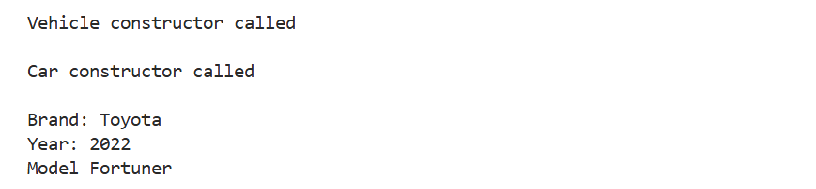
Output:

